Project - High Level Design
on
Multimodal Education Creator

Course Name: Gen AI

Institution Name: Medicaps University – Datagami Skill Based Course

Student Name(s) & Enrolment Number(s):
Sr no | Student Name | Enrolment Number
1 | Leeni Patidar | EN22CS301554
2 | Mahak Agrawal | EN22CS301563
3 | Kunal Singh Chouhan | EN22CS301540
4 | Krishna Patidar | EN22CS301523

Group Name: 04D5
Project Number: GAI-04
Industry Mentor Name:
University Mentor Name: Prof. Veenita Rathore
Academic Year: 2025-2026

Table of Contents
1. Introduction
1.1. Scope of the Document
1.2. Intended Audience
1.3. System Overview
2. System Design
2.1. Application Design
2.2. Process Flow
2.3. Information Flow
2.4. Components Design
2.5. Key Design Considerations
2.6. API Catalogue
3. Data Design
3.1. Data Model
3.2. Data Access Mechanism
3.3. Data Retention Policies
3.4. Data Migration
4. Interfaces
5. State and Session Management
6. Caching
7. Non-Functional Requirements
7.1. Security Aspects
7.2. Performance Aspects
8. References

- Introduction
The Multimodal Generative Artificial Intelligence Education Concept Visualization System is a comprehensive, AI-driven learning platform designed to address the limitations of traditional education methods by providing a richer and more interactive learning experience. In conventional systems, learners primarily depend on textual explanations, which can be insufficient for understanding complex, abstract, or highly technical topics. This often leads to reduced engagement, lower retention, and difficulty in conceptual clarity. The proposed system overcomes these challenges by leveraging advanced Generative Artificial Intelligence technologies to convert a single user input into multiple forms of educational content, including detailed textual explanations, contextually relevant visual representations, and structured flashcards for revision.
The system uses a Large Language Model such as Grok-1 for generating high-quality, context-aware textual content. This model is capable of understanding complex queries, maintaining context, and producing logically structured explanations suitable for educational purposes. For visual content generation, the system integrates models available through Hugging Face, such as Stable Diffusion, which generate diagrams and illustrations directly from textual descriptions. These visuals help learners better understand and retain concepts by providing a graphical representation alongside text.
The combination of text generation, image synthesis, and flashcard creation forms a multimodal learning environment where users can read, visualize, and revise simultaneously. This significantly enhances comprehension, supports different learning styles, and improves knowledge retention. The system is designed with a modular and scalable architecture, ensuring flexibility, ease of maintenance, and the ability to integrate future advancements in artificial intelligence. It is suitable for a wide range of applications, including academic education, technical training, self-learning platforms, and professional development.

1.1 Scope of the Document
This document provides a detailed and structured description of the Multimodal Generative Artificial Intelligence Education System, covering all aspects related to its architecture, design, implementation, and operational workflow. It defines the scope and boundaries of the system, ensuring a clear understanding of what the system is intended to do and how it achieves its objectives. The document includes a comprehensive explanation of the system architecture, detailing the roles and interactions of the frontend interface, backend processing layer, artificial intelligence services, and data storage components.
It further elaborates on module-level design, including prompt processing, integration with the Grok-1 Large Language Model for text generation, integration with Hugging Face models such as Stable Diffusion for image generation, and the logic used for flashcard creation. The document describes the complete process flow in a step-by-step manner, starting from user input, through backend processing and AI model interaction, to final output generation and display. It also explains the information flow between different components, ensuring clarity on how data moves within the system.
Additionally, the document addresses important technical considerations such as system performance optimization using asynchronous processing, scalability to support multiple concurrent users, secure handling of API keys and user data, and cost optimization strategies to reduce unnecessary API usage. It includes details about database usage for storing generated content and vector database implementation for enabling semantic search and efficient retrieval of information. The document serves multiple purposes, including acting as a development guide for engineers, a validation reference for testers, and an evaluation document for academic and industry stakeholders. It ensures consistency in development by clearly defining expected inputs, outputs, workflows, and system behavior.

1.2 Intended Audience
This document is intended for a diverse group of stakeholders involved in the design, development, deployment, evaluation, and usage of the system. Software developers can use this document to gain a clear understanding of the system architecture, component interactions, and implementation details, enabling them to efficiently develop, maintain, and extend different modules of the application. Artificial intelligence and machine learning engineers can refer to the integration details of the Grok-1 Large Language Model and Hugging Face image generation models to optimize prompt engineering, improve response quality, and enhance system performance.
System architects can evaluate the design decisions, modular structure, scalability, and reliability of the system, ensuring that it meets both academic and industry standards. Test engineers and quality assurance teams can use the document to design test cases, validate workflows, and ensure that all system components function correctly under different conditions. Academic faculty members and project evaluators can assess the innovation, technical depth, and practical implementation of Generative Artificial Intelligence within the system.
In addition, students and researchers can use this document as a reference to understand how multimodal artificial intelligence can be applied in real-world educational systems. The document is written in a clear, structured, and formal manner to ensure accessibility and ease of understanding for both technical and non-technical audiences, enabling effective communication among all stakeholders.

  - System Overview

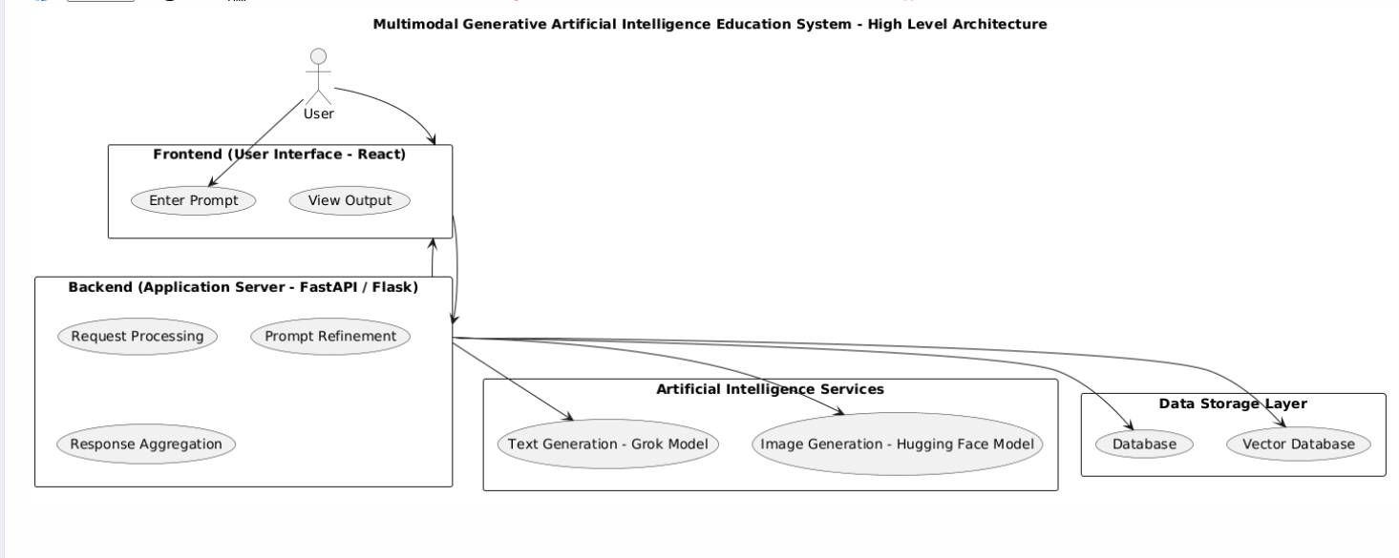
Figer1.1 High-Level Architecture Diagram

The system is designed to accept a user-defined input in the form of a topic, concept, or question and transform it into comprehensive multimodal educational content. When a user enters a prompt through the frontend interface, the input is transmitted to the backend server via an API request. The backend validates the input, performs preprocessing, and refines the prompt using prompt engineering techniques to improve the quality and relevance of the generated output.
The refined prompt is then sent to the Grok-1 Large Language Model, which generates a detailed, structured, and context-aware textual explanation. This explanation typically includes definitions, key concepts, examples, and logical breakdowns to make the topic easier to understand. The same prompt is also sent to an image generation model through Hugging Face, such as Stable Diffusion, which produces a relevant visual representation, such as a diagram or illustration, to support the textual explanation.
After generating the textual content, the system processes the output to identify important points and converts them into flashcards in a question-and-answer format. These flashcards serve as a revision tool, helping users quickly recall key information and reinforce learning. All generated outputs, including text, image references, and flashcards, are stored in a database for future access and analysis. Additionally, embeddings of the content can be generated and stored in a vector database, enabling semantic search functionality where users can retrieve relevant content based on meaning rather than exact keyword matches.
The backend then aggregates all outputs and sends them to the frontend, where they are displayed in a structured and user-friendly interface. Users can view explanations, interact with images, and review flashcards seamlessly within a single platform. The system ensures efficient processing, scalability, and reliability, making it a powerful tool for enhancing modern education through the integration of Generative Artificial Intelligence technologies.

2.System Design
The Multimodal Generative Artificial Intelligence Education System is designed using a modular and scalable client-server architecture that enables efficient processing and delivery of multimodal educational content. The primary objective of the system design is to transform a single user input into multiple meaningful outputs, including detailed textual explanations, visual representations, and flashcards. The architecture is divided into distinct layers such as the user interface layer, backend processing layer, artificial intelligence services layer, and data storage layer. Each layer is responsible for a specific set of tasks, ensuring separation of concerns and improving system maintainability.
The frontend layer provides an interactive interface for users to input queries and view outputs. It communicates with the backend using RESTful APIs. The backend layer acts as the core of the system, handling request processing, validation, prompt refinement, and communication with external AI services. The artificial intelligence layer includes the Grok-1 Large Language Model for text generation and Hugging Face models such as Stable Diffusion for image generation. These models work together to produce multimodal outputs. The data storage layer includes both traditional databases for storing generated content and vector databases for enabling semantic search.
The system is designed to support asynchronous processing, allowing text and image generation tasks to run concurrently, thereby reducing response time. It also ensures flexibility so that different models or services can be replaced without affecting the overall system. The architecture supports scalability, allowing the system to handle increasing user requests efficiently. Overall, the system design focuses on performance, reliability, and extensibility, making it suitable for real-world educational applications.
2.1 Application Design
The application design follows a layered architecture that organizes the system into different functional components, ensuring clarity, maintainability, and scalability. The frontend is developed using React and serves as the user interface where users can input prompts and view outputs such as explanations, images, and flashcards. It provides a dynamic and responsive experience, ensuring ease of interaction. The frontend communicates with the backend through well-defined RESTful APIs.
The backend is developed using Python frameworks such as FastAPI or Flask and acts as the central processing unit of the system. It handles incoming requests, performs validation, refines user prompts, and coordinates with artificial intelligence services. It also manages response aggregation and formatting before sending results back to the frontend. The backend ensures efficient communication between different components and maintains system logic.
The artificial intelligence services layer includes the Grok-1 Large Language Model for generating textual content and Hugging Face models such as Stable Diffusion for generating images. These models are integrated through APIs and are responsible for producing high-quality outputs based on user input. The system also includes a flashcard generation module that extracts key points from the generated text and converts them into question-answer pairs.
The data storage layer consists of a traditional database for storing user inputs and outputs, and a vector database for storing embeddings. The vector database enables semantic search, allowing users to retrieve relevant content efficiently. The application design ensures that all components work together seamlessly to provide a complete multimodal learning experience.

2.2 Process Flow
The process flow of the system describes the sequence of steps involved in converting user input into multimodal educational content. The process begins when a user enters a prompt through the frontend interface. This prompt is sent to the backend server via an API request. The backend validates the input and performs preprocessing, including prompt refinement to ensure better quality outputs from artificial intelligence models.
The refined prompt is then sent to the Grok-1 Large Language Model, which generates a detailed textual explanation of the topic. This explanation includes definitions, key concepts, and examples. At the same time, the prompt is sent to the Hugging Face image generation model, such as Stable Diffusion, which generates a relevant visual representation of the concept. These processes may occur sequentially or in parallel, depending on system implementation.
After generating the textual output, the system processes it to extract important points and converts them into flashcards. These flashcards are structured in a question-answer format, enabling quick revision and reinforcement of learning. All generated outputs, including text, image references, and flashcards, are then stored in the database. If a vector database is used, embeddings of the content are also stored for semantic search.
Finally, the backend aggregates all outputs and sends them to the frontend, where they are displayed to the user. The process flow ensures efficient data processing, smooth integration of components, and timely delivery of results.
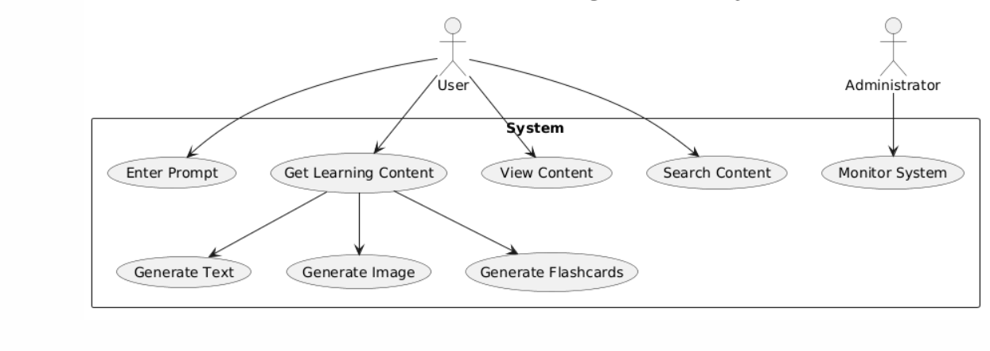
Figer 2.1Use case Diagram
2.3 Information Flow
The information flow in the system defines how data moves between different components from input to output. It begins with the user entering a prompt through the frontend interface. The frontend sends this input to the backend server using an API request. The backend acts as the central controller, receiving the request and initiating processing.
The backend first validates and refines the prompt, ensuring that it is suitable for artificial intelligence models. The refined prompt is then sent to the Grok-1 Large Language Model, which processes the input and generates a structured textual response. This response is sent back to the backend. Simultaneously or sequentially, the backend sends the prompt to the Hugging Face image generation model, which generates an image and returns it to the backend.
The backend then processes the generated text to create flashcards by extracting key concepts and converting them into question-answer pairs. All outputs are combined into a single response. The backend also stores the data in the database and generates embeddings for storage in the vector database.
Finally, the processed information is sent back to the frontend, where it is displayed to the user. The information flow ensures efficient communication between components, smooth data transformation, and consistent output delivery.
2.4 Components Design
The system consists of multiple components, each designed to perform specific tasks within the overall architecture. The user interface component is responsible for capturing user input and displaying outputs in an interactive format. It ensures a seamless user experience. The backend component handles request processing, business logic, and coordination between different services. It acts as the central hub of the system.
The language model component, based on Grok-1, generates textual explanations and structured content. The image generation component, using Hugging Face models such as Stable Diffusion, produces visual representations of concepts. The flashcard generation component processes textual output to create concise question-answer pairs for revision.
The database component stores user inputs, generated outputs, and system logs, ensuring data persistence. The vector database component stores embeddings and enables semantic search, improving content retrieval. The API component provides endpoints for communication between frontend and backend. Each component is designed to be modular, allowing easy updates and integration of new technologies.
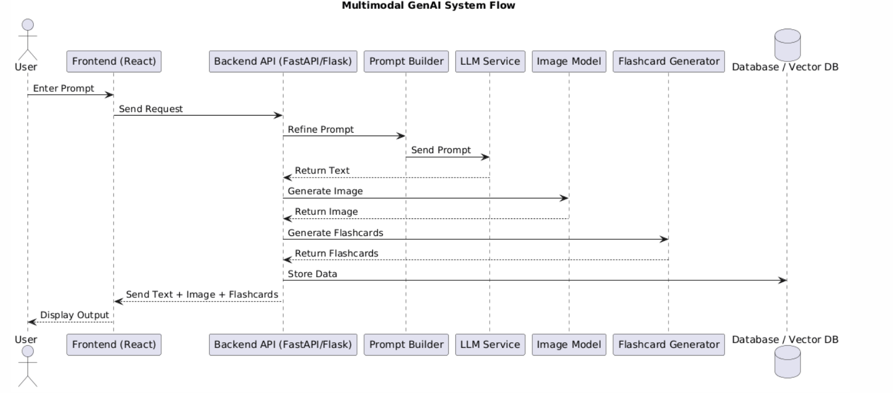
Figer2.2 sequence Diagram

2.5 Key Design Considerations
The system is designed with several key considerations to ensure optimal performance and reliability. Fast response time is achieved through asynchronous processing, allowing multiple operations to run concurrently. Scalability is ensured through a modular architecture, enabling the system to handle increasing user loads. Security is maintained through proper API key management, request validation, and protection of user data.
Accuracy of output is improved through prompt engineering and the use of advanced language models. The modular design allows easy upgrades and integration of new technologies. Cost optimization is achieved by reducing unnecessary API calls, using caching mechanisms, and leveraging vector search. These considerations ensure that the system is efficient, reliable, and suitable for real-world use.
2.6 API Catalogue
The system provides a set of RESTful APIs to handle various functionalities. The Generate Content API processes user input and generates text, images, and flashcards. The Save Content API stores generated outputs in the database. The Fetch Content API retrieves stored content based on a unique identifier. The Search Content API enables semantic search using the vector database. The Health Check API monitors system status. These APIs ensure smooth communication between frontend and backend and support efficient system operation.
3.Data Design

The data design of the Multimodal Generative Artificial Intelligence Education System is structured to efficiently handle, store, and retrieve multimodal content generated from user inputs. The system manages different types of data, including textual explanations, image references, flashcards, user prompts, metadata, and vector embeddings. Since the system combines both structured and unstructured data, it uses a hybrid storage approach that includes a traditional database for structured records and a vector database for semantic search capabilities.
The primary goal of the data design is to ensure high performance, scalability, consistency, and reliability while supporting fast access and retrieval of information. Every user interaction generates a content record that is stored along with associated outputs. These records are indexed and organized in a way that allows efficient querying based on identifiers, timestamps, or semantic similarity. The design also supports future extensibility, enabling the addition of new data fields, models, or features without major structural changes Data validation and normalization are applied before storing any information to maintain consistency and avoid redundancy. The system also ensures secure handling of sensitive information such as API keys and user-related data. Logging mechanisms are implemented to track system activity, monitor performance, and support debugging. Additionally, caching strategies may be used to temporarily store frequently accessed data, reducing database load and improving response time. The data design is optimized to support real-time generation and retrieval of educational content while maintaining system efficiency and reliability.

3.1 Data Model

The data model defines the structure, format, and relationships of data stored within the system. The central entity in the model is the “Content” entity, which represents the complete output generated from a single user prompt. Each content record includes a unique identifier, the original user prompt, generated textual explanation, image reference or URL, flashcards, timestamps, and additional metadata such as processing time, model used, and response status.
Flashcards are modeled as a collection of question-answer pairs associated with a specific content record. This relationship is typically one-to-many, where one content record can contain multiple flashcards. Image data is not stored directly as raw files in most cases but is referenced using URLs or storage paths, ensuring efficient storage management.
The system also includes a vector data model where embeddings of textual content are stored. These embeddings are numerical representations of text generated using machine learning models, enabling semantic similarity search. Each embedding is linked to its corresponding content record, allowing retrieval of related information based on meaning rather than exact text matching.
The data model is designed to support both relational databases (such as MySQL or PostgreSQL) and non-relational databases (such as MongoDB), depending on implementation requirements. It ensures flexibility, allowing easy modification or extension of data structures as the system evolves.

3.2 Data Access Mechanism
The data access mechanism defines how data is created, retrieved, updated, and managed within the system. All data interactions are handled through backend APIs, which act as an interface between the frontend and the database. When a user generates content, the backend processes the request and stores the resulting data in the database using structured queries or object-relational mapping techniques.
Data retrieval is performed through API endpoints that allow fetching content based on unique identifiers or search queries. For example, when a user requests previously generated content, the backend queries the database and returns the corresponding record. Efficient indexing is used to speed up query performance, especially for large datasets.
For semantic search functionality, the system uses a vector database such as FAISS or Pinecone. When a search query is received, it is converted into an embedding and compared with stored embeddings to find the most relevant matches. This enables advanced search capabilities that go beyond simple keyword matching.
The system may also implement caching mechanisms to store frequently accessed data temporarily, reducing database load and improving response time. Data access layers are designed to separate business logic from database operations, improving maintainability and scalability. Proper validation, error handling, and access control mechanisms are implemented to ensure secure and reliable data operations.

3.3 Data Retention Policies
Data retention policies define how long data is stored, how it is managed over time, and when it is deleted or archived. The system is designed to retain generated educational content, including text, images, and flashcards, for future access and reuse. The retention period can be configured based on system requirements, such as storing data for a fixed duration or until it is manually deleted by the user or administrator.
To optimize storage usage, the system may implement strategies such as archiving older data, compressing stored content, and removing duplicate or unused records. Vector embeddings may also be periodically updated or pruned to maintain the efficiency of the semantic search system.
Security and privacy are important aspects of data retention. Sensitive data is protected through encryption and access control mechanisms. User data is handled according to privacy guidelines, ensuring that it is not misused or exposed. Logs generated by the system are retained for monitoring and debugging purposes but are managed to prevent excessive storage consumption.
Automated cleanup processes may be implemented to remove outdated or irrelevant data, ensuring that the system remains efficient and responsive. These policies help maintain a balance between data availability and system performance.

3.4 Data Migration

Data migration refers to the process of transferring data between systems, databases, or formats, which is essential for system upgrades, scaling, or integration with new technologies. The system is designed to support smooth and reliable data migration by maintaining consistent data structures and using standardized formats such as JSON for data exchange.
Migration may be required when upgrading database systems, changing schema structures, or moving from on-premise storage to cloud-based infrastructure. The migration process typically involves extracting existing data, transforming it into the required format, and loading it into the new system. Care is taken to ensure that no data is lost or corrupted during this process.
Version control and schema management techniques are used to handle changes in data structure over time. Backups are created before migration to prevent data loss in case of failure. Validation checks are performed after migration to ensure data integrity and consistency.
To minimize system downtime, strategies such as incremental migration, parallel system operation, or phased migration may be used. These approaches allow the system to continue functioning while data is being transferred. Overall, the data migration process is designed to be secure, efficient, and reliable, ensuring continuity of system operations and supporting future scalability.

4. Interfaces
The Multimodal Generative Artificial Intelligence Education System includes multiple interfaces that enable communication and interaction between different components of the system as well as with external services. These interfaces ensure smooth data exchange, modular integration, and efficient functioning of the entire application. The primary interfaces in the system include the user interface, backend application programming interface, artificial intelligence service interfaces, and data storage interfaces.
The user interface is developed using React and serves as the point of interaction between the user and the system. It allows users to enter prompts, view generated textual explanations, visualize images, and interact with flashcards. The interface is designed to be responsive, intuitive, and user-friendly, ensuring a seamless learning experience. It communicates with the backend through HTTP requests and receives processed data in structured formats such as JSON.
The backend interface is implemented using frameworks such as FastAPI or Flask and acts as the central communication layer of the system. It exposes RESTful API endpoints that handle various functionalities, including content generation, data storage, retrieval, and search operations. The backend receives requests from the frontend, processes them, and interacts with artificial intelligence services and databases. It also ensures proper request validation, error handling, and response formatting.
The artificial intelligence service interfaces connect the backend with external AI models used for content generation. The system integrates the Grok-1 Large Language Model for generating textual explanations and Hugging Face models such as Stable Diffusion for image generation. These interfaces involve sending refined prompts to the respective models and receiving generated outputs in return. Proper handling of API keys, request limits, and response parsing is essential for maintaining system performance and reliability.
The data storage interface connects the backend with the database and vector database systems. It is responsible for storing generated content, retrieving previously saved data, and managing embeddings for semantic search. Structured queries and data access layers are used to ensure efficient interaction with the database.
Overall, the interfaces are designed to be modular, secure, and scalable, allowing seamless integration between system components and external services while ensuring efficient data flow and reliable system operation.
5. State and Session Management
State and session management in the Multimodal Generative Artificial Intelligence Education System is designed to ensure a smooth, consistent, and secure user experience while maintaining high scalability and performance. The system primarily follows a stateless backend architecture, which means that each request from the user is processed independently without relying on stored session data on the server. This design choice reduces server overhead, simplifies scaling, and allows the system to handle a large number of concurrent users efficiently. All necessary information required for processing, such as the user prompt and request parameters, is included in each API request.
On the frontend, state management plays a critical role in maintaining user interaction and application behavior. The React-based interface manages different types of state, including input state (user prompt), output state (generated text, image, and flashcards), loading indicators, and error states. This ensures that the user interface updates dynamically without requiring full page reloads. For more complex scenarios, global state management techniques can be used to share data across multiple components, improving consistency and reducing redundancy.
Session management is implemented using token-based approaches when user authentication is required. Technologies such as JSON Web Tokens can be used to securely identify users across multiple requests. Each token contains encoded user information and is validated by the backend for every request. This eliminates the need for server-side session storage while ensuring secure access control. Session expiration and refresh mechanisms are implemented to enhance security and prevent unauthorized access.
The system may also maintain short-lived session-like data, such as recently generated content, to improve user experience. This can be stored in the frontend memory or temporary backend storage. Additionally, the system includes mechanisms for handling session timeouts, user logout, and cleanup of temporary data. Error handling and recovery strategies are also implemented to ensure that the system remains stable even if a session is interrupted. Overall, the state and session management strategy ensures responsiveness, scalability, security, and a seamless user experience.

6. Caching
Caching in the Multimodal Generative Artificial Intelligence Education System is implemented as a key performance optimization strategy to reduce latency, minimize computational overhead, and improve overall system efficiency. Since generating content using artificial intelligence models such as Grok-1 and image generation models can be resource-intensive and time-consuming, caching helps avoid redundant processing by storing previously generated results and reusing them when similar requests are received.
The system employs caching at multiple levels. At the backend level, responses generated for user prompts, including text explanations, image references, and flashcards, can be stored in a cache. When a new request matches or closely resembles a previously processed query, the system can retrieve the cached result instead of invoking the AI models again. This significantly reduces response time and lowers operational costs associated with API usage.
In-memory caching systems such as Redis can be used to store frequently accessed data for fast retrieval. These systems provide high-speed access to cached data and are particularly useful in handling high traffic scenarios. The system may also implement query-level caching, where results of database queries are temporarily stored to avoid repeated database access. On the frontend, caching mechanisms such as browser storage or in-memory storage can be used to store recent results, reducing unnecessary API calls and improving user experience.
The system includes cache management strategies to ensure data consistency and relevance. Each cached entry is associated with a time-to-live value, after which it expires and is removed or refreshed. Cache invalidation mechanisms are implemented to update or remove outdated data when underlying content changes. Additionally, semantic caching can be integrated with the vector database, where similar queries are matched based on meaning rather than exact text, further enhancing efficiency.
Security considerations are also taken into account in caching, ensuring that sensitive data is not stored in an insecure manner. Proper access control and encryption techniques can be applied where necessary. Overall, caching improves system performance by reducing response time, optimizing resource usage, and enhancing scalability, making the system more efficient and user-friendly.

7. Non-Functional Requirements
The non-functional requirements of the Multimodal Generative Artificial Intelligence Education System define the quality attributes that ensure the system operates efficiently, reliably, and securely under different conditions. These requirements focus on aspects such as performance, scalability, usability, security, and maintainability rather than specific functionalities. The system is designed to handle multiple user requests simultaneously while maintaining consistent response times and output quality. It supports scalability through a modular architecture, allowing individual components such as backend services, artificial intelligence models, and databases to be scaled independently based on demand.
Reliability is ensured by implementing proper error handling, fallback mechanisms, and system monitoring to maintain continuous operation even in case of partial failures. The system is designed to provide high availability, ensuring that users can access services without interruption. Usability is also an important requirement, with a focus on providing a simple, intuitive, and responsive user interface that enhances the learning experience.
Maintainability is achieved through a clean and modular code structure, enabling developers to easily update or extend system components. Compatibility is considered to ensure that the system works across different devices and platforms, including web browsers and mobile environments. The system also incorporates logging and monitoring mechanisms to track performance, detect issues, and support debugging. Overall, these non-functional requirements ensure that the system delivers a high-quality user experience while maintaining efficiency, scalability, and reliability.
7.1 Security Aspects
Security is a critical aspect of the system design, ensuring that user data, system resources, and external integrations are protected from unauthorized access and misuse. The system implements secure communication protocols such as HTTPS to protect data transmitted between the frontend and backend. API keys used for accessing artificial intelligence services are securely stored and managed, preventing exposure to unauthorized users.
Authentication and authorization mechanisms can be implemented to control access to system features, ensuring that only authorized users can perform specific actions. Token-based authentication methods such as JSON Web Tokens may be used to securely identify users across multiple requests. Input validation is performed on all user inputs to prevent malicious data from affecting system operations, reducing the risk of attacks such as injection or cross-site scripting.
Data stored in the database is protected using appropriate security measures, including access control and encryption where necessary. Sensitive information is not exposed in API responses, and proper error handling ensures that system details are not leaked. The system also includes logging and monitoring mechanisms to detect suspicious activities and respond to potential security threats. Regular updates and adherence to security best practices help maintain a secure and robust system environment.
7.2 Performance Aspects
Performance is a key consideration in the system, as it directly impacts user experience and system efficiency. The system is designed to provide fast and responsive outputs despite the computational complexity involved in generating text and images using artificial intelligence models. Asynchronous processing is used to handle multiple tasks concurrently, allowing text generation, image generation, and flashcard creation to occur in parallel, thereby reducing overall response time.
Caching mechanisms are implemented to store frequently requested data and previously generated results, minimizing repeated computations and reducing latency. Efficient database querying and indexing are used to ensure fast data retrieval, even as the حجم of stored data increases. The system also supports load balancing and horizontal scaling, enabling it to handle a large number of concurrent users without performance degradation.
Performance monitoring tools are used to track system metrics such as response time, throughput, and resource utilization. These insights help identify bottlenecks and optimize system performance. The use of optimized algorithms, efficient API calls, and proper resource management further enhances system speed and reliability. Overall, the system is designed to deliver high performance, ensuring quick and consistent responses for all users.
8. References
The development of the Multimodal Generative Artificial Intelligence Education System is supported by a combination of advanced artificial intelligence models, modern web development frameworks, and efficient data processing technologies. These tools and technologies play a crucial role in enabling text generation, image synthesis, backend processing, semantic search, and overall system integration. Large Language Models such as Grok-1, developed by xAI, are used for generating detailed, context-aware textual explanations and structured educational content. These models provide strong reasoning capabilities and help in transforming user input into meaningful and comprehensive learning material.
For image generation, the system utilizes models available through Hugging Face such as Stable Diffusion, which generate high-quality images and diagrams based on textual prompts. These visual representations enhance understanding by providing graphical support to textual explanations. Backend development is carried out using Python frameworks such as FastAPI and Flask, which handle API routing, request processing, and integration with artificial intelligence services. These frameworks support asynchronous operations, enabling faster and more efficient system performance.
The frontend of the system is developed using React, which provides a dynamic and responsive user interface for interacting with the system. For data storage and retrieval, the system uses traditional databases along with vector databases such as FAISS and Pinecone. These vector databases store embeddings of textual data and enable semantic search, allowing users to retrieve relevant content based on meaning rather than exact keywords.
In addition to these core technologies, the system also incorporates techniques such as prompt engineering for improving the quality of AI-generated outputs, caching mechanisms for performance optimization, and secure API handling for protecting sensitive data. These combined technologies and methodologies enable the system to deliver a robust, scalable, and efficient multimodal learning platform.

